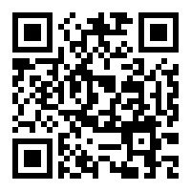Smart Rock V3

Thank you for purchasing our latest revision of the Smart Rock. We have documented how to get started on the GitHub Wiki in the Operation Guide.

Contact: [halebroc@oregonstate.edu](mailto:halebroc@oregonstate.edu)

|  |  |
| --- | --- |
| Quantity | Item |
|  |  |
|  |  |
|  |  |